Sponsored by Flagstaff Family and Community Services and Flagstaff’s Informed Response Sharing Team (FIRST)

Applicant’s Name_______________________________________________________

Address______________________________________________________________

Telephone_____________________________________________________________

Email address_________________________________________________________

Name of College/University______________________________________________

Program applying for___________________________________________________

List up to three careers or occupations you are considering. If you don’t know yet, indicate “uncertain”
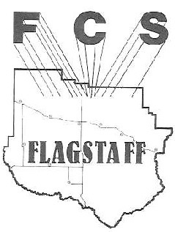
1.__________________________________________________________________
The Gail Watt Annual Scholarship in Human Services

2.__________________________________________________________________

3.__________________________________________________________________

Please give a brief outline of your future plans when graduating from your chosen program

______________________________________________________________________

______________________________________________________________________

______________________________________________________________________

______________________________________________________________________

Please list your volunteer involvement in the community

______________________________________________________________________

______________________________________________________________________
______________________________________________________________________
______________________________________________________________________

Please list any extracurricular activities you are involved in

______________________________________________________________________

______________________________________________________________________
______________________________________________________________________
Please list summer or part-time jobs you have held

______________________________________________________________________

______________________________________________________________________

______________________________________________________________________

Please, in 250 words or less, explain why you are applying for the Gail Watt Annual Scholarship in Human Services.

______________________________________________________________________

______________________________________________________________________

______________________________________________________________________

______________________________________________________________________

______________________________________________________________________

______________________________________________________________________

______________________________________________________________________

______________________________________________________________________

______________________________________________________________________

______________________________________________________________________

______________________________________________________________________
______________________________________________________________________

